A1:

1. Random Access.

2. Sequential Access.

3. Direct Access.

A2: A word is an ordered set of bytes or bits that is the normal unit in which information may be stored, transmitted, or operated on within a given computer.

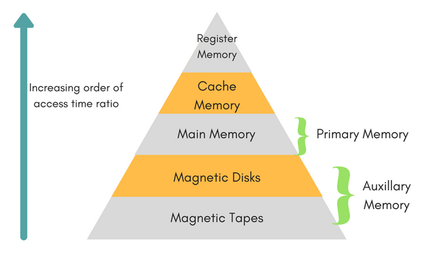A3: The memory hierarchy separates computer storage into a hierarchy based on response time.

The storage devices in an increasing order of access time ratio:

1. Magnetic Tapes.

2. Magnetic Disks.

3. Main Memory.

4. Cache Memory.

5. Register Memory.